**Query 1: Retrieve List of All Database**

1. **EXEC** sp_helpdb

**Example:**

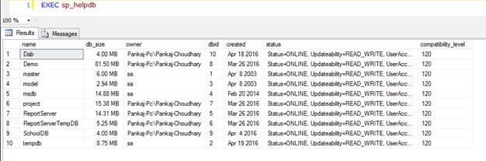

**Query 2: Display Text of Stored Procedure, Trigger, View**

1. **exec** sp_helptext @objname = 'Object_Name'

**Example:**

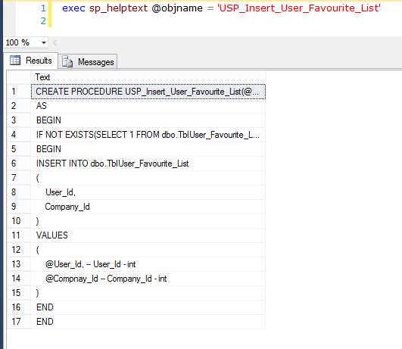

**Query 3: Get All Stored Procedure Relate To Database**

1. **SELECT** **DISTINCT** o.**name**, o.xtype
3. **FROM** syscomments c
5. **INNER** JOIN sysobjects o **ON** c.id=o.id
7. **WHERE** o.xtype='P'

**Example:**

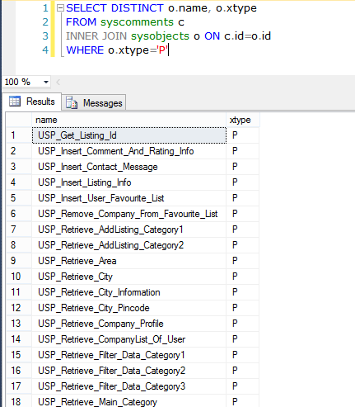

To retrieve the View use “V” instead of “P” and for functions use “FN.

**Query 4: Get All Stored Procedure Relate To Table**

1. **SELECT** **DISTINCT** o.**name**, o.xtype
3. **FROM** syscomments c
5. **INNER** JOIN sysobjects o **ON** c.id=o.id
7. **WHERE** c.TEXT LIKE '%Table_Name%' AND o.xtype='P'

**Example:**

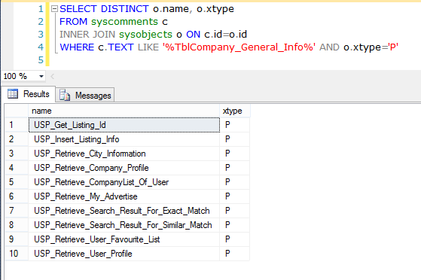

To retrieve the View use “V” instead of “P” and for functions use “FN.

**Query 5: Rebuild All Index of Database**

1. **EXEC** sp_MSforeachtable @command1="print '?' DBCC DBREINDEX ('?', ' ', 80)"
3. GO
5. **EXEC** sp_updatestats
7. GO

**Example:**

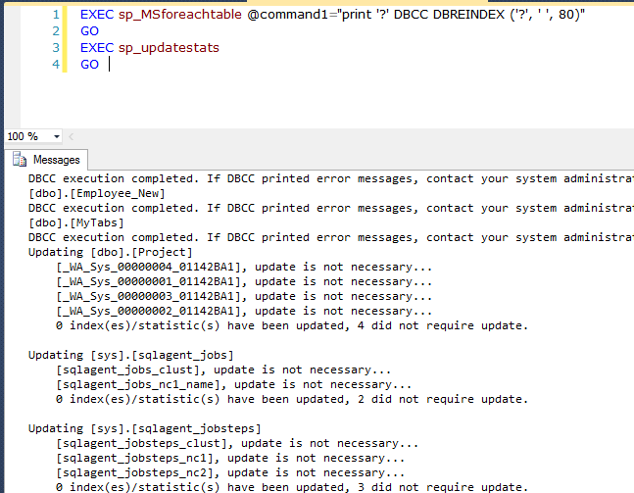

**Query 6: Retrieve All dependencies of Stored Procedure:**

This query return all objects name that are using into stored procedure like table, user define function, another stored procedure.

**Query:**

1. ;**WITH** stored_procedures **AS** (
3. **SELECT**
5. oo.**name** **AS** table_name,
7. ROW_NUMBER() OVER(partition **by** o.**name**,oo.**name** **ORDER** **BY** o.**name**,oo.**name**) **AS** row
9. **FROM** sysdepends d
11. **INNER** JOIN sysobjects o **ON** o.id=d.id
13. **INNER** JOIN sysobjects oo **ON** oo.id=d.depid
15. **WHERE** o.xtype = 'P' AND o.**name** LIKE '%SP_NAme%' )
17. **SELECT** Table_name **FROM** stored_procedures
19. **WHERE** row = 1

**Example:**

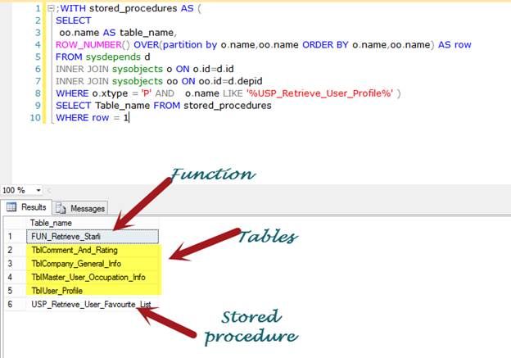

**Query 7: Find Byte Size Of All tables in database**

1. **SELECT** sob.**name** **AS** Table_Name,
3. SUM(sys.length) **AS** [Size_Table(Bytes)]
5. **FROM** sysobjects sob, syscolumns sys
7. **WHERE** sob.xtype='u' AND sys.id=sob.id
9. **GROUP** **BY** sob.**name**

**Example:**

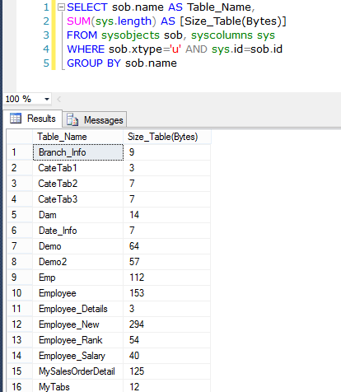

**Query 8: Get all table that don’t have identity column:**

**Query:**

1. **SELECT**
3. TABLE_NAME **FROM** INFORMATION_SCHEMA.TABLES
5. **where**
7. Table_NAME NOT IN
9. (
11. **SELECT** **DISTINCT** c.TABLE_NAME **FROM** INFORMATION_SCHEMA.COLUMNS c
13. **INNER**
15. JOIN sys.identity_columns ic
17. **on**
19. (c.COLUMN_NAME=ic.**NAME**))
21. AND
23. TABLE_TYPE ='BASE TABLE'

**Example:**

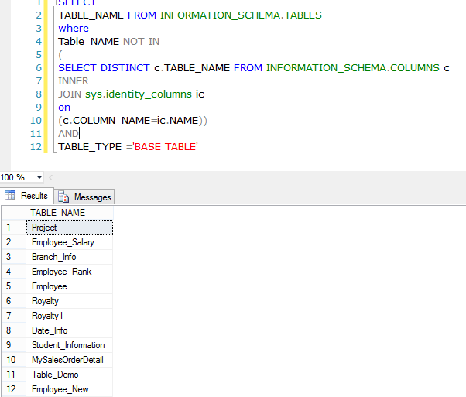

**Query 9:** **List of Primary Key and Foreign Key for Whole Database**

1. **SELECT**
3. **DISTINCT**
5. Constraint_Name **AS** [**Constraint**],
7. Table_Schema **AS** [**Schema**],
9. Table_Name **AS** [TableName] **FROM** INFORMATION_SCHEMA.KEY_COLUMN_USAGE
11. GO

**Example:**

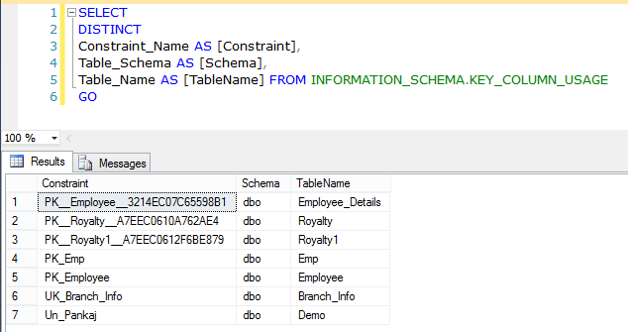

**Query 10:** **List of Primary Key and Foreign Key for a particular table**

1. **SELECT**
3. **DISTINCT**
5. Constraint_Name **AS** [**Constraint**],
7. Table_Schema **AS** [**Schema**],
9. Table_Name **AS** [TableName] **FROM** INFORMATION_SCHEMA.KEY_COLUMN_USAGE
11. **WHERE** INFORMATION_SCHEMA.KEY_COLUMN_USAGE.TABLE_NAME='Table_Name'
13. GO

**Example:**

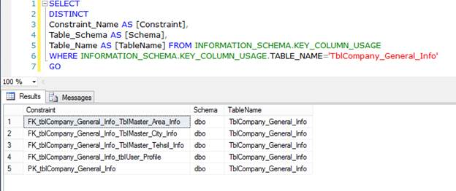

**Query 11: RESEED Identity of all tables**

1. **EXEC** sp_MSForEachTable '
3. IF OBJECTPROPERTY(object_id(''?''), ''TableHasIdentity'') = 1
5. DBCC CHECKIDENT (''?'', RESEED, 0)

**Example:**

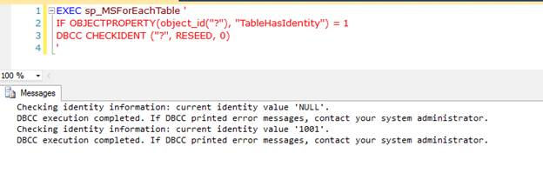

**Query 12: List of tables with number of records**

1. **CREATE** **TABLE** #Tab
3. (
5. Table_Name [**varchar**](**max**),
7. Total_Records **int**
9. );
11. **EXEC** sp_MSForEachTable @command1=' Insert Into #Tab(Table_Name, Total_Records) SELECT ''?'', COUNT(*) FROM ?'
13. **SELECT** * **FROM** #Tab t **ORDER** **BY** t.Total_Records **DESC**;
15. **DROP** **TABLE** #Tab;

**Example:**

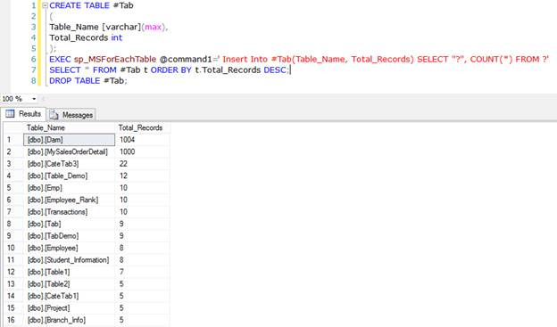

**Query 13: Get the version name of SQL Server**

1. **SELECT** @@VERSION **AS** Version_Name

**Example:**

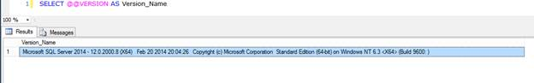

**Query 14: Get Current Language of SQL Server**

1. **SELECT** @@LANGUAGE **AS** Current_Language;

**Example:**

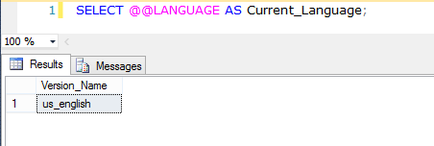  
**Query 15: Disable all constraints of a table**

1. **ALTER** **TABLE** Table_Name NOCHECK **CONSTRAINT** ALL

**Example:**

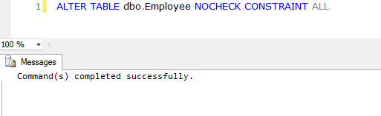

**Query16: Disable all constraints of all tables**

1. **EXEC** sp_MSForEachTable 'ALTER TABLE ? NOCHECK CONSTRAINT ALL'

**Example:**

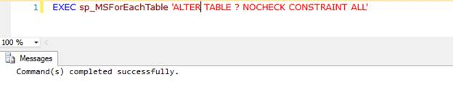**Query 17: Get Current Language Id**

1. **SELECT** @@LANGID **AS** 'Language ID'

**Example:**

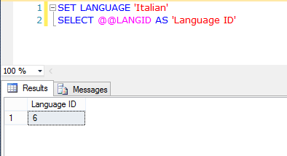

**Query18: Get precision level used by decimal and numeric as current set in Server:**

1. **SELECT** @@MAX_PRECISION **AS** 'MAX_PRECISION'

**Example:**

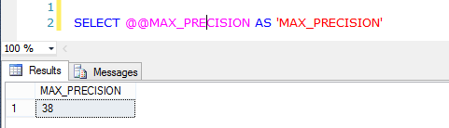

**Query 19: Return Server Name of SQL Server**

1. **SELECT** @@SERVERNAME **AS** 'Server_Name'

**Example:**

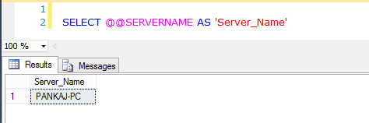

**Query 20: Get name of register key under which SQL Server is running**

1. **SELECT** @@SERVICENAME **AS** 'Service_Name'

**Example:**

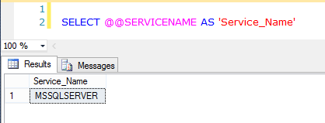

**Query 21: Get Session Id of current user process**

1. **SELECT** @@SPID **AS** 'Session_Id'

**Example:**

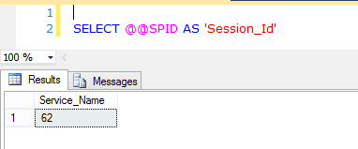

**Query22: Get Current Value of TEXTSIZE option**

1. **SELECT** @@TEXTSIZE **AS** 'Text_Size'

**Example:**

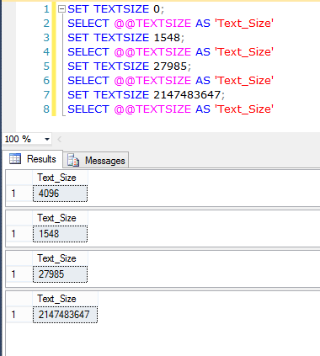

**Query 23: Retrieve Free Space of Hard Disk**

1. **EXEC** master..xp_fixeddrives

**Example:**

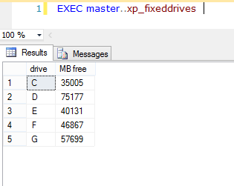

**Query24:** **Disable a Particular Trigger  
  
Syntax:**

1. **ALTER** **TABLE** Table_Name DISABLE **TRIGGER** Trigger_Name

**Example:**

1. **ALTER** **TABLE** Employee DISABLE **TRIGGER** TR_Insert_Salary

**Query 25:** **Enable a Particular Trigger**

**Syntax:**

1. **ALTER** **TABLE** Table_Name ENABLE **TRIGGER** Trigger_Name

**Example:**

1. **ALTER** **TABLE** Employee ENABLE **TRIGGER** TR_Insert_Salary

**Query 26:** **Disable All Trigger of a table**

We can disable and enable all triggers of a table using previous query, but replacing the "ALL" instead of trigger name.  
  
**Syntax:**

1. **ALTER** **TABLE** Table_Name DISABLE **TRIGGER** ALL

**Example:**

1. **ALTER** **TABLE** Demo DISABLE **TRIGGER** ALL

**Query 27:** **Enable All Trigger of a table**

1. **ALTER** **TABLE** Table_Name ENABLE **TRIGGER** ALL

**Example:**

1. **ALTER** **TABLE** Demo ENABLE **TRIGGER** ALL

**Query 28:** **Disable All Trigger for database**

Using sp_msforeachtable system stored procedure we enable and disable all triggers for a database.

**Syntax:**

1. Use Database_Name
3. **Exec** sp_msforeachtable "ALTER TABLE ? DISABLE TRIGGER all"

**Example:**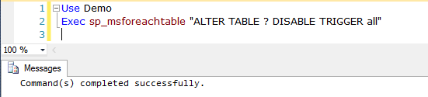

**Query29:** **Enable All Trigger for database**

1. Use Demo
3. **Exec** sp_msforeachtable "ALTER TABLE ? ENABLE TRIGGER all"

**Example:**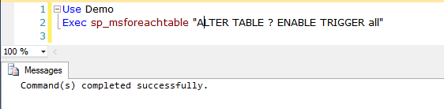

**Query30:** **List of Stored procedure modified in last N days**

1. **SELECT** **name**,modify_date
3. **FROM** sys.objects
5. **WHERE** type='P'
7. AND DATEDIFF(D,modify_date,GETDATE())< N

**Example:**

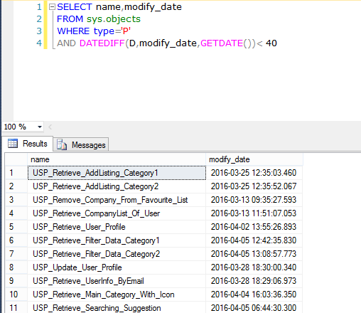

**Query31:** **List of Stored procedure created in last N days**

1. **SELECT** **name**,sys.objects.create_date
3. **FROM** sys.objects
5. **WHERE** type='P'
7. AND DATEDIFF(D,sys.objects.create_date,GETDATE())< N

**Example:**

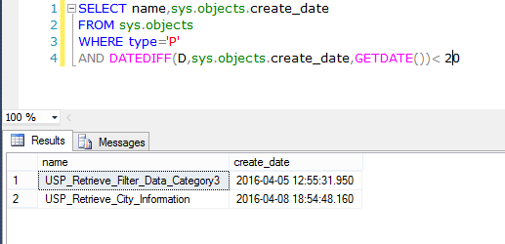

**Query32: Recompile a stored procedure**

1. **EXEC** sp_recompile'Procedure_Name';
3. GO

Example:

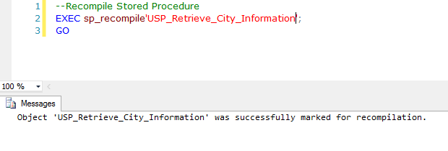

**Query 33:** **Recompile all stored procedure on a table**

1. **EXEC** sp_recompile N'Table_Name';
3. GO

**Example:**

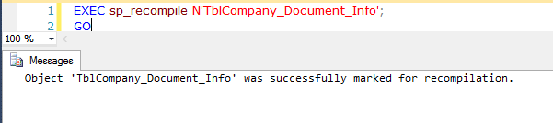

**Query 34: Get all columns of a specific data type:**

**Query:**

1. **SELECT** OBJECT_NAME(c.OBJECT_ID) **as** Table_Name, c.**name** **as** Column_Name
3. **FROM** sys.columns **AS** c
5. JOIN sys.types **AS** t **ON** c.user_type_id=t.user_type_id
7. **WHERE** t.**name** = 'Data_Type'

**Example:**

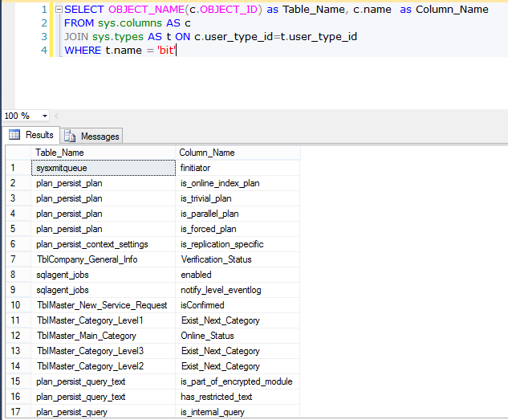

**Query 35: Get all Nullable columns of a table**

1. **SELECT** OBJECT_NAME(c.OBJECT_ID) **as** Table_Name, c.**name** **as** Column_Name
3. **FROM** sys.columns **AS** c
5. JOIN sys.types **AS** t **ON** c.user_type_id=t.user_type_id
7. **WHERE** c.is_nullable=0 AND OBJECT_NAME(c.OBJECT_ID)='Table_Name'

**Example:**

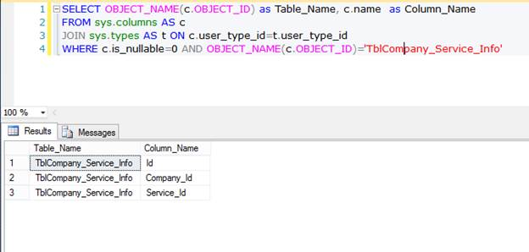

**Query 36: Get All table that don’t have primary key**

1. **SELECT** **name** **AS** Table_Name
3. **FROM** sys.tables
5. **WHERE** OBJECTPROPERTY(OBJECT_ID,'TableHasPrimaryKey') = 0
7. **ORDER** **BY** Table_Name;

**Example:**

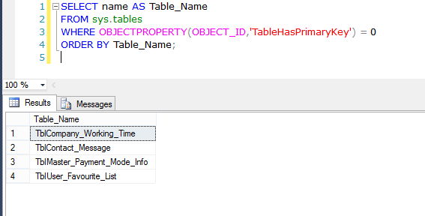

**Query 37: Get All table that don’t have foreign key**

1. **SELECT** **name** **AS** Table_Name
3. **FROM** sys.tables
5. **WHERE** OBJECTPROPERTY(OBJECT_ID,'TableHasForeignKey') = 0
7. **ORDER** **BY** Table_Name;

**Example:**

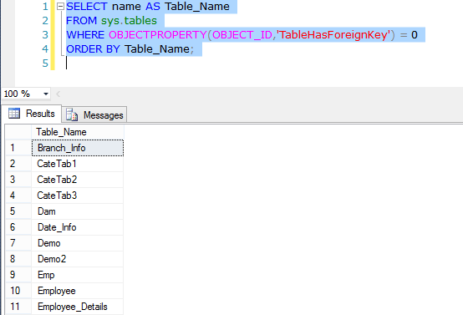

**Query 38: Get All table that don’t have identity column**

1. **SELECT** **name** **AS** Table_Name
3. **FROM** sys.tables
5. **WHERE** OBJECTPROPERTY(OBJECT_ID,'TableHasIdentity') = 0
7. **ORDER** **BY** Table_Name;

**Example:**

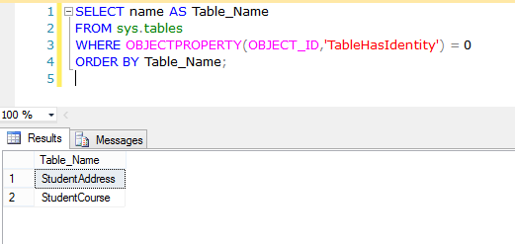  
**Query 39: Get First Date of Current Month**

1. **SELECT** CONVERT(**VARCHAR**(25),DATEADD(DAY,-(DAY(GETDATE()))+1,GETDATE()),105) First_Date_Current_Month;

**Example:**

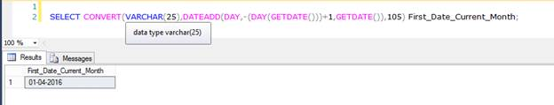

**Query 40: Get last date of previous month**

1. **SELECT** CONVERT(**VARCHAR**(25),DATEADD(DAY,-(DAY(GETDATE())),GETDATE()),105) Last_Date_Previous_Month;

**Example:**

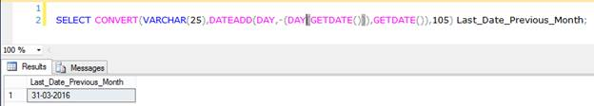

**Query 41: Get last date of current month**

1. **SELECT** CONVERT(**VARCHAR**(25),DATEADD(DAY,-(DAY(GETDATE())), DATEADD(MONTH,1,GETDATE())),105) Last_Date_Current_Month;

**Example:**

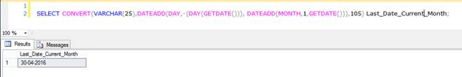

**Query 42: Get first date of next month**

1. **SELECT** CONVERT(**VARCHAR**(25),DATEADD(DAY,-(DAY(GETDATE())), DATEADD(MONTH,1,GETDATE())+1),105) First_Date_Next_Month;

**Example:**

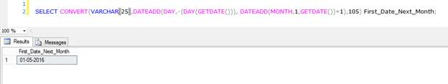

**Query 43: Swap the values of two columns**

1. **UPDATE** Table_Name **SET** Column1=Column2, Column2=Column1

**Example:**

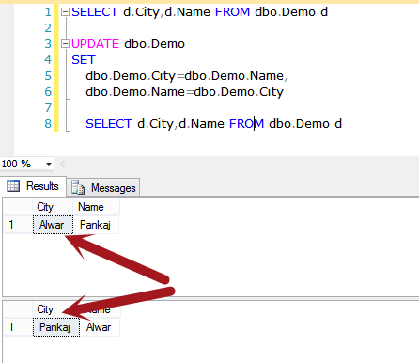

**Query 44: Remove all stored procedure from database**

1. **Declare** @Drop_SP Nvarchar(**MAX**)
3. **Declare** My_Cursor **Cursor** **For** **Select** [**name**] **From** sys.objects **where** type = 'p'
5. **Open** My_Cursor
7. **Fetch** **Next** **From** My_Cursor **Into** @Drop_SP
9. While @@FETCH_STATUS= 0
11. **Begin**
13. **Exec**('DROP PROCEDURE ' + @Drop_SP)
15. **Fetch** **Next** **From** My_Cursor **Into** @Drop_SP
17. **End**
19. **Close** My_Cursor
21. **Deallocate** My_Cursor

**Example:**

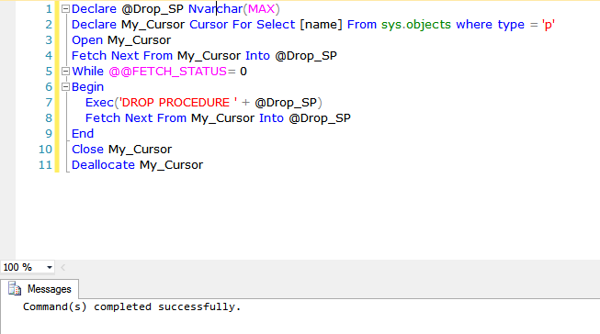  
**Query 45: Remove all views from database**

1. **Declare** @Drop_View Nvarchar(**MAX**)
3. **Declare** My_Cursor **Cursor** **For** **Select** [**name**] **From** sys.objects **where** type = 'v'
5. **Open** My_Cursor
7. **Fetch** **Next** **From** My_Cursor **Into** @Drop_View
9. While @@FETCH_STATUS = 0
11. **Begin**
13. **Exec**('DROP VIEW ' + @Drop_View)
15. **Fetch** **Next** **From** My_Cursor **Into** @Drop_View
17. **End**
19. **Close** My_Cursor
21. **Deallocate** My_Cursor

**Example:**

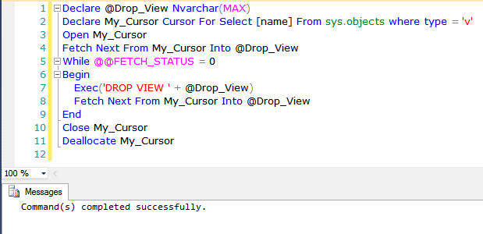

**Query 46: Drop all tables**

1. **EXEC** sys.sp_MSforeachtable @command1 = 'Drop Table ?'

**Example:**

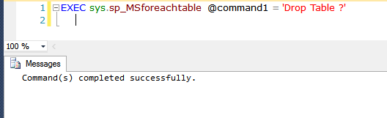

**Query 47: Get information of tables’ columns**

1. **SELECT** * **FROM** INFORMATION_SCHEMA.COLUMNS
3. **WHERE** INFORMATION_SCHEMA.COLUMNS.TABLE_NAME=’Table_Name’

**Example:**

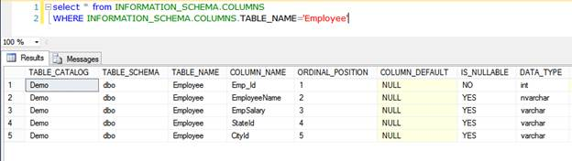

**Query 48: Get all columns contain any constraints**

1. **SELECT** TABLE_NAME,COLUMN_NAME,CONSTRAINT_NAME **FROM** INFORMATION_SCHEMA.CONSTRAINT_COLUMN_USAGE

**Example:**

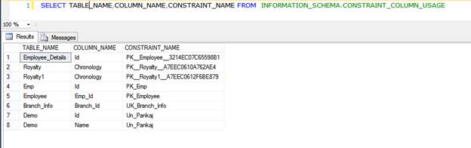

**Query 49: Get all tables that contain a view**

1. **SELECT** * **FROM** INFORMATION_SCHEMA.VIEW_TABLE_USAGE

**Example:**

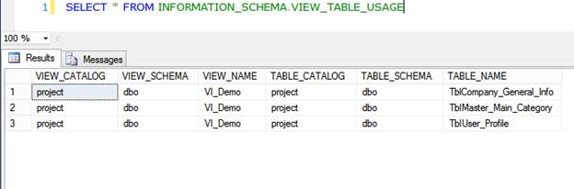

**Query 50: Get all columns of table that using in views**

1. **SELECT** * **FROM** INFORMATION_SCHEMA.VIEW_COLUMN_USAGE

**Example:**

